Name: | ___________________________________________________ |  |  | Date: ___________
 | Year 9 Mathematics  Test 2, 2015  Topics – Pythagoras and Area |  |  | 
45

= %

CALCULATOR ASSUMED
Time: | 55 minutes
Reading: | 5 minutes | Equipment Allowed: | ½ page of one sided note, calculator
Working: | 50 minutes

1. | [6 marks: 1, 1, 1, 1, 1, 1 ]
 | Complete the following sentences using the words or expressions below. Note that you may not need to use all the words:
area circle diagram hypotenuse
length perimeter right angle
square units volume
a) | The longest side of a right-angled triangle is called the _______________________________.
b) | The hypotenuse is always situated opposite the _______________________________.
c) | When using Pythagoras’ theorem, always check the _______________________________ given for each measurement.
d) | The _______________________________ of a shape is a measure of the amount of surface enclosed by the shape.
e) | The _______________________________ of a shape is the distance around the outside of a shape.
f) | π is used to calculate the perimeter and area of a _______________________________.
2. | [1 mark]  Circle the correct answer
 | Which of the following statements is true for the given diagram?
 | 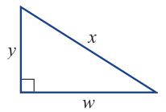 | A y² – w² = x² B x² – w² = y²  C y² – x² = w² D w² – x² = y²  E w² – y² = x²

 | 3. |  | [4 marks: 2, 2]
 |  |  | Determine the perimeter of the following shapes:
 | a) |  | 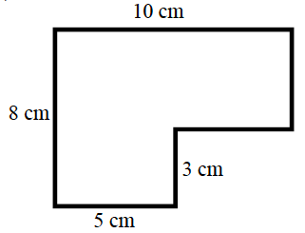 | b) | 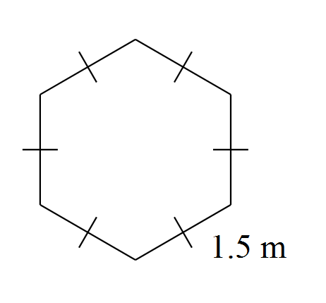
 | 4. |  | [7 marks: 1, 2, 2, 2]
 |  |  | Determine the area of the following shapes:
 | a) |  | 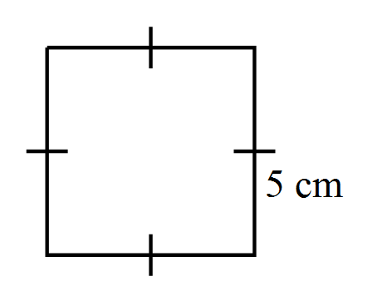 | b) | 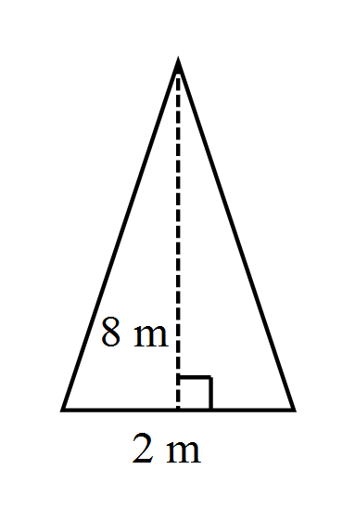  12m
 | c) |  | 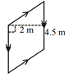  3m | d) | 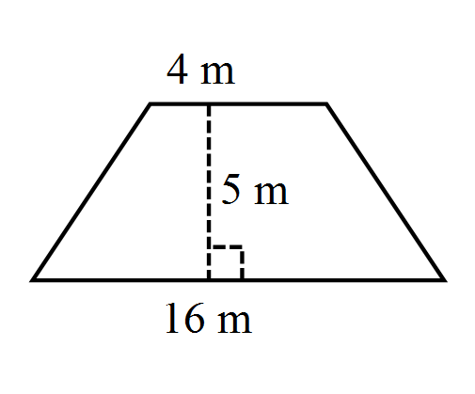  12m

5. | [3 Mark]  Find the length of the missing dimension ‘x’. Show working out.  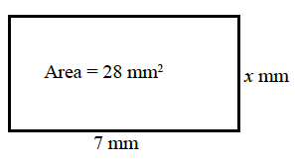

6. | [6 marks: 3, 3]
 | Calculate the length of the unknown side in each of the following triangles, give answers to 2 decimal places where appropriate.
a) | 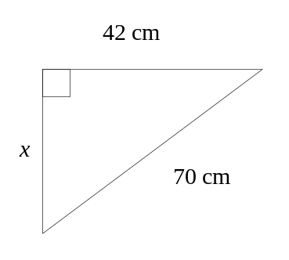 | b) | 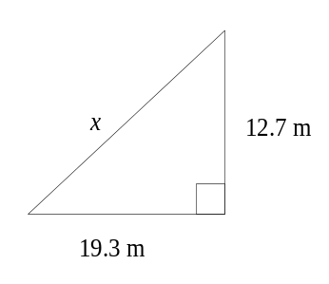

7. | [5 marks]
Two buildings are directly opposite one another, either side of a 15m wide street. One building is 25m tall the other is 40m tall.
a) Sketch a diagram of the situation.
b) What is the exact diagonal distance between the top of the two buildings?

8. |  | [9 marks: 2, 3, 2, 2]
 |  | Determine the area of the following shapes:
a) |  | 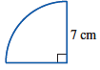 | b) | 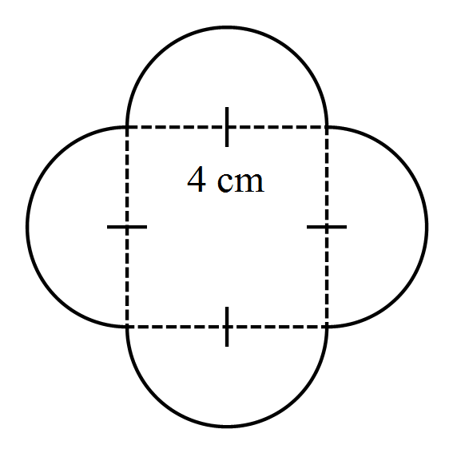
a) |  | Note: express your answer in cm².  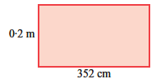 | b) | 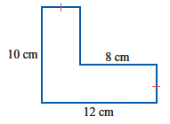

9. | [4 marks: 2, 2]
 | Calculate the area of the following sectors.
a) | b)
 | 